**Query / Find Documents**

**1.Get all documents.**

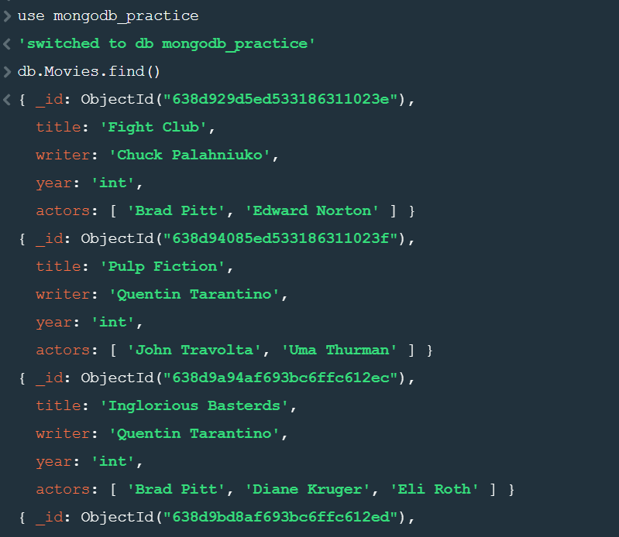

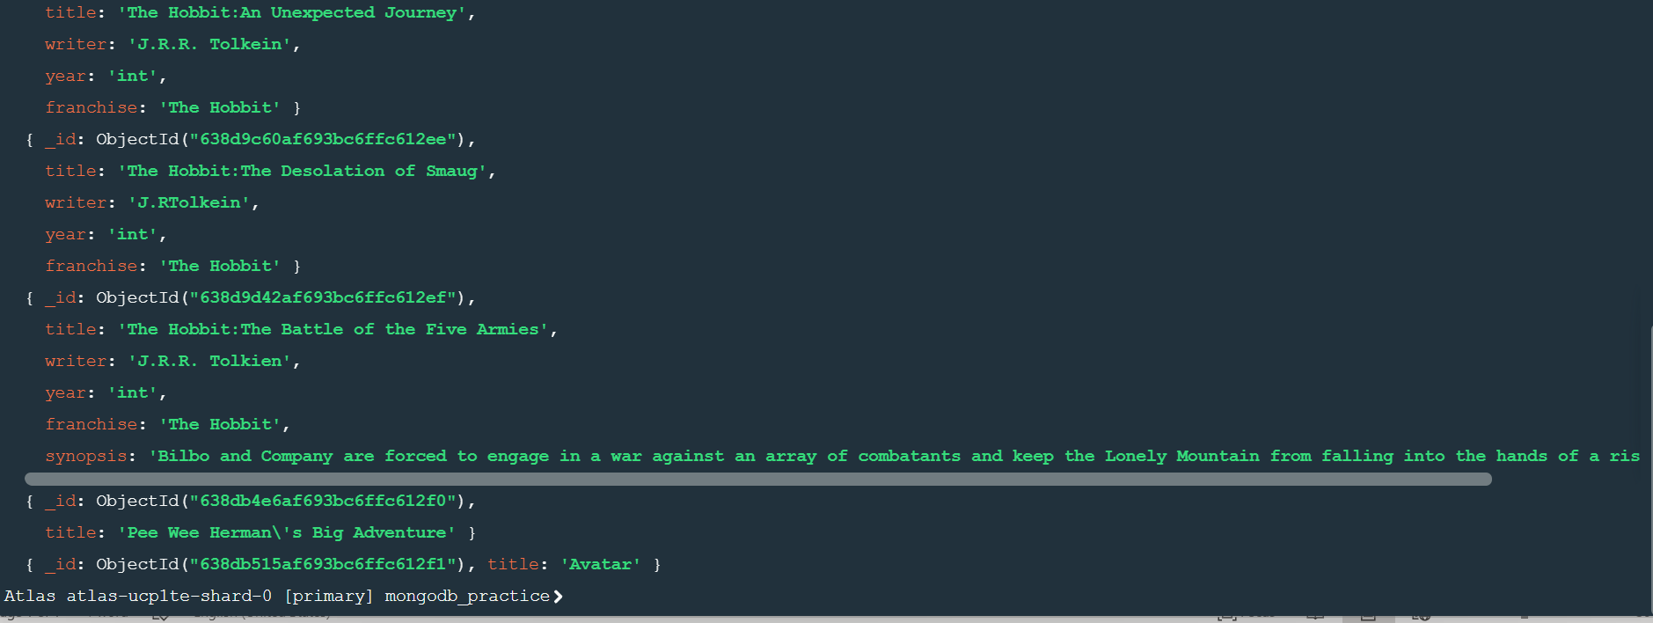

**2.Get all documents with writer set to "Quentin Tarantino".**

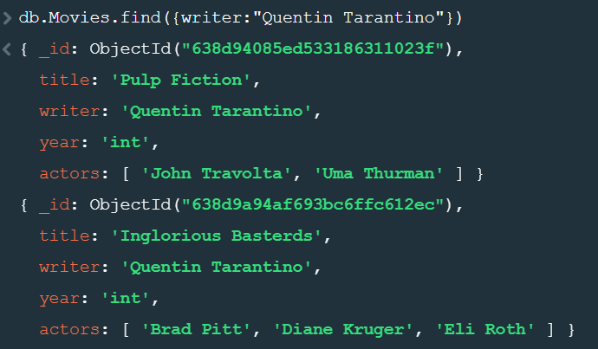

**3.Get all documents where actors include "Brad Pitt"**

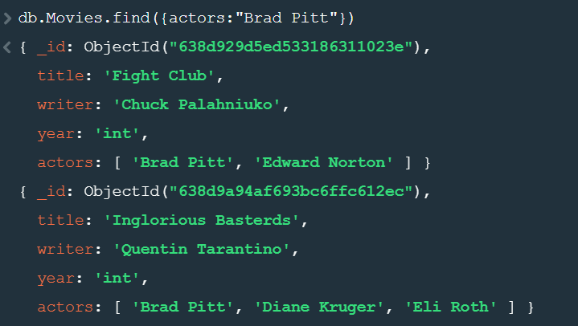

**4.Get all documents with franchise set to "The Hobbit".**

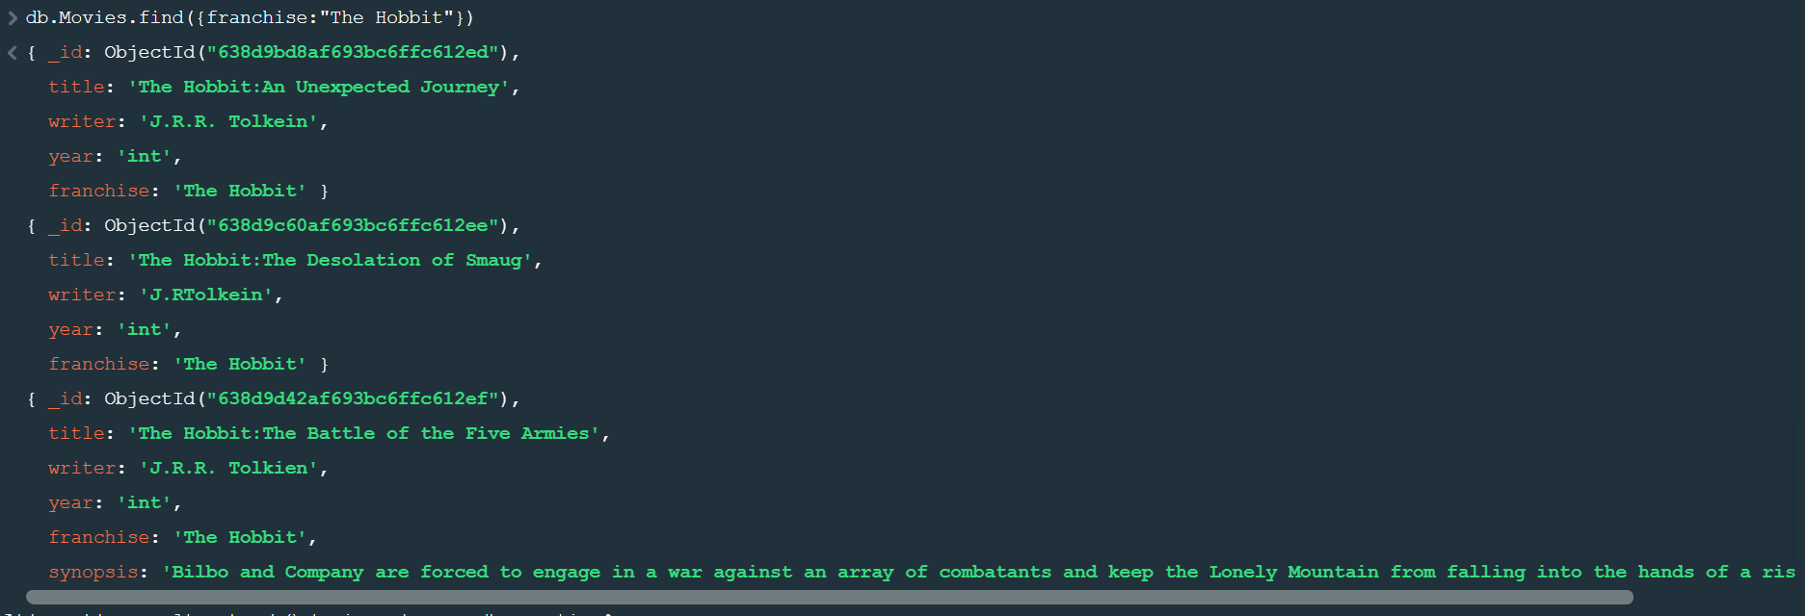

**5.Get all movies released in the 90s.**

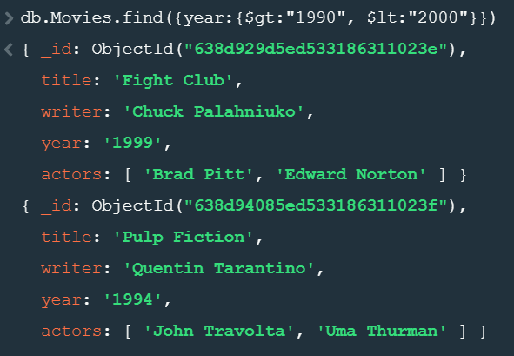

**6.Get all movies released before the year 2000 or after 2010.**

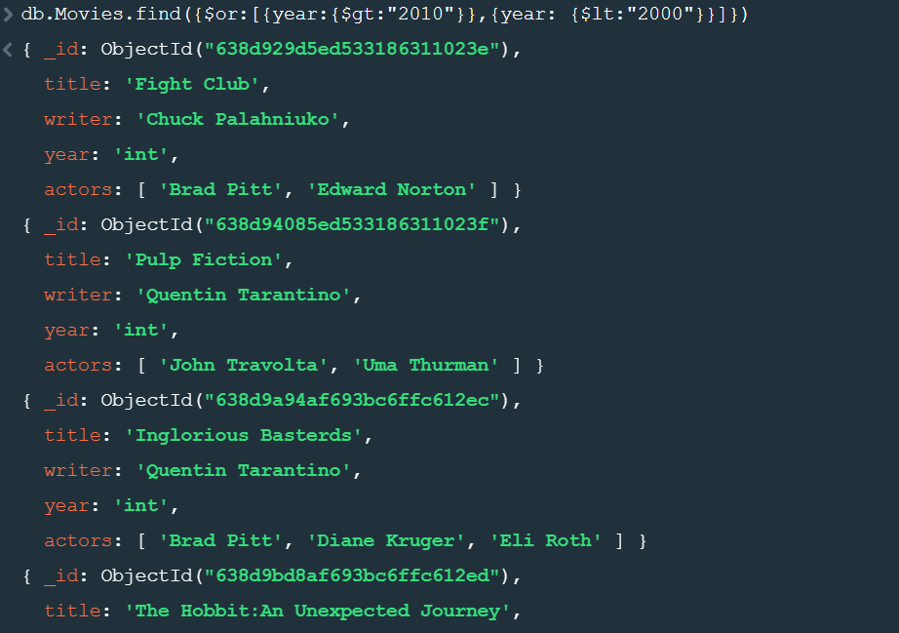

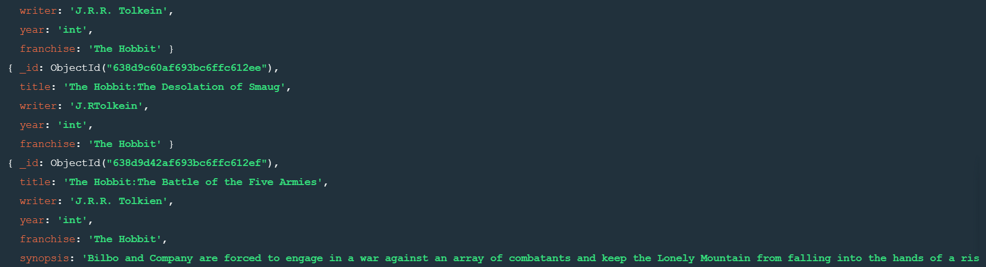

**Update Documents**

**1.Add a synopsis to "The Hobbit: An Unexpected Journey" : "A reluctant hobbit, Bilbo Baggins, sets out to the Lonely Mountain with a spirited group of dwarves to reclaim their mountain home - and the gold within it - from the dragon Smaug."**

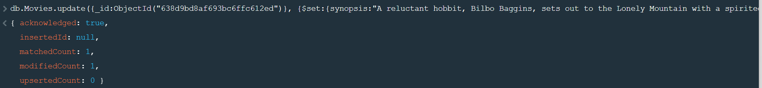

**2.Add a synopsis to "The Hobbit: The Desolation of Smaug" : "The dwarves, along with Bilbo Baggins and Gandalf the Grey, continue their quest to reclaim Erebor, their homeland, from Smaug. Bilbo Baggins is in possession of a mysterious and magical ring."**

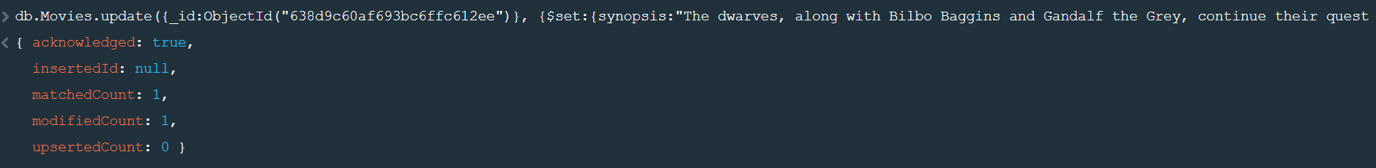

**3.Add an actor named "Samuel L. Jackson" to the movie "Pulp Fiction".**

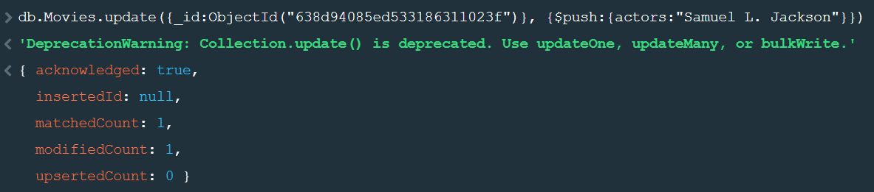

**Text Search**

**1.Find all movies that have a synopsis that contains the word "Bilbo".**

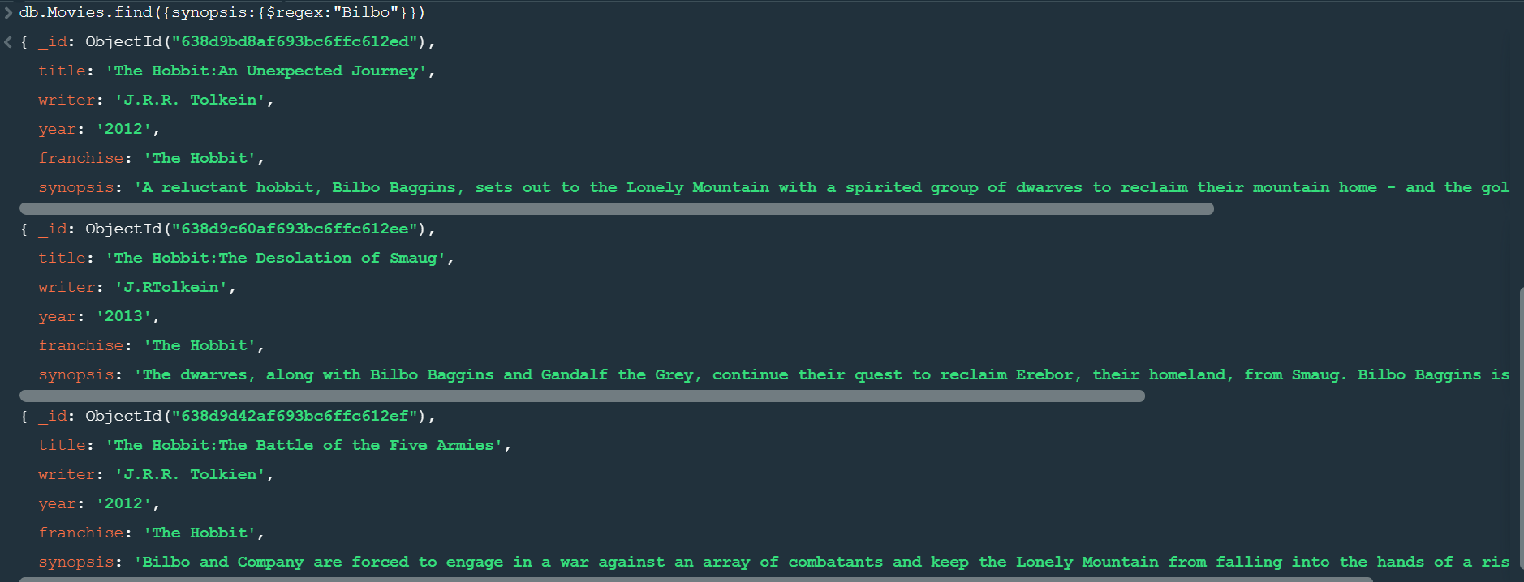

**2.Find all movies that have a synopsis that contains the word "Gandalf".**

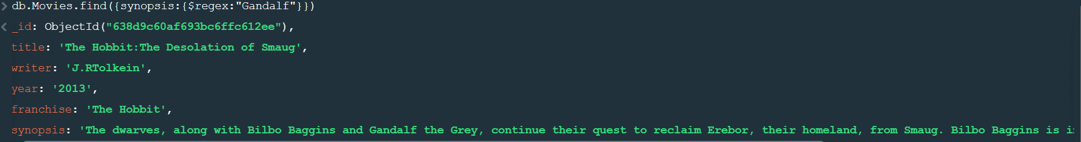

**3.Find all movies that have a synopsis that contains the word "Bilbo" and not the word "Gandalf".**

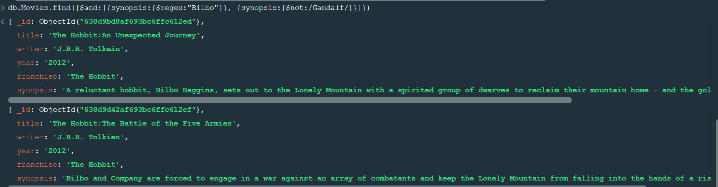

**4.Find all movies that have a synopsis that contains the word "dwarves" or "hobbit".**

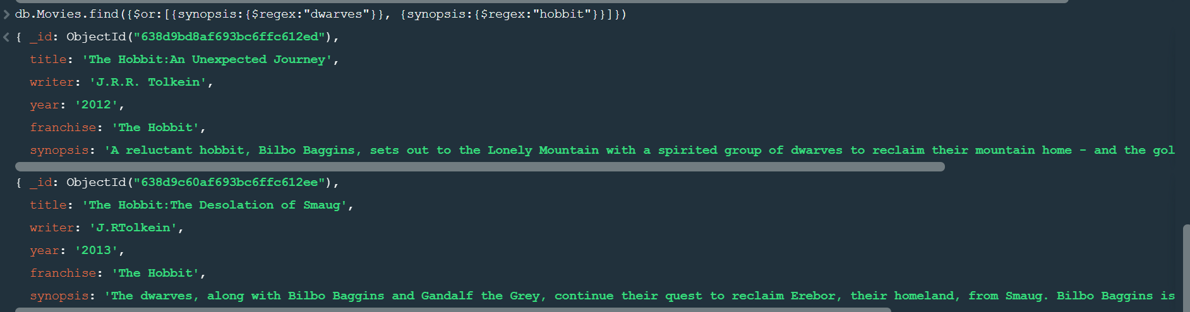

**5.Find all movies that have a synopsis that contains the word "gold" and "dragon".**

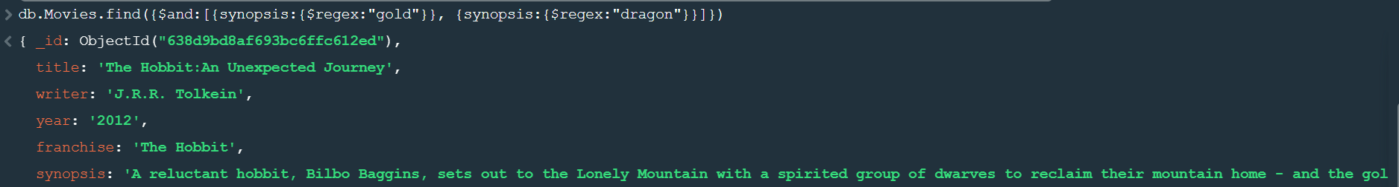

**Delete Documents**

**1.Delete the movie "Pee Wee Herman's Big Adventure".**



**2. Delete the movie "Avatar".**

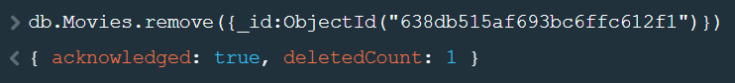

**Relationships**

**1.Insert the following documents into a users collection.**

**Username : GoodGuyGreg**

**First_name : "Good Guy"**

**Last_name : "Greg"**



**2.username : ScumbagSteve**

**full_name :**

**first : "Scumbag"**

**last : "Steve"**



### **3. Insert the following documents into a posts collection**

**username : GoodGuyGreg**

**title : Passes out at party**

**body : Wakes up early and cleans house**



**4.username : GoodGuyGreg**

**title : Steals your identity**

**body : Raises your credit score**



**5.username : GoodGuyGreg**

**title : Reports a bug in your code**

**body : Sends you a Pull Request**



**6.username : ScumbagSteve**

**title : Borrows something**

**body : Sells it**

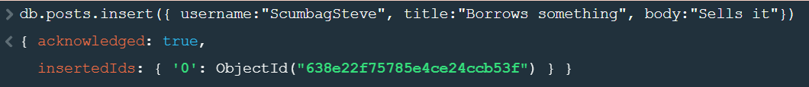

**7.username : ScumbagSteve**

**title : Borrows everything**

**body : The end**

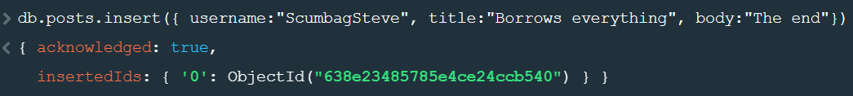

**8.username : ScumbagSteve**

**title : Forks your repo on github**

**body : Sets to private**

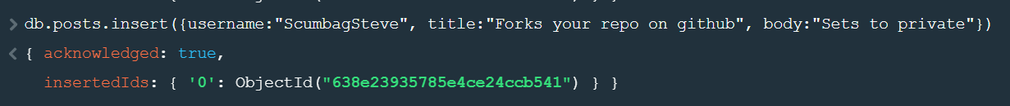**2.Insert the following documents into a comments collection**

**username : GoodGuyGreg**

**comment : Hope you got a good deal!**

**post : [post_obj_id]**

**where [post_obj_id] is the ObjectId of the posts document: "Borrows something".**



**username : GoodGuyGreg**

**comment : What's mine is yours!**

**post : [post_obj_id]**

**where [post_obj_id] is the ObjectId of the posts document: "Borrows everything".**



**username : GoodGuyGreg**

**comment : Don't violate the licensing agreement!**

**post : [post_obj_id]**

**where [post_obj_id] is the ObjectId of the posts document: "Forks your repo on github”.**



**username : ScumbagSteve**

**comment : It still isn't clean**

**post : [post_obj_id]**

**where [post_obj_id] is the ObjectId of the posts document: "Passes out at party".**



**username : ScumbagSteve**

**comment : Denied your PR cause I found a hack**

**post : [post_obj_id]**

**where [post_obj_id] is the ObjectId of the posts document: "Reports a bug in your code".**



## Querying related collections

**1.Find all users.**

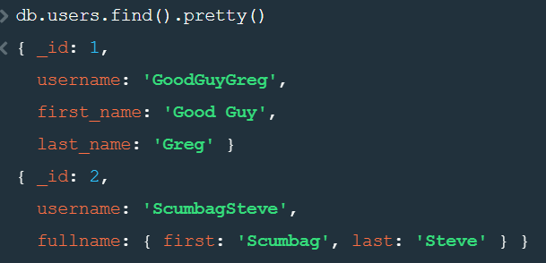

**2.Find all posts.**

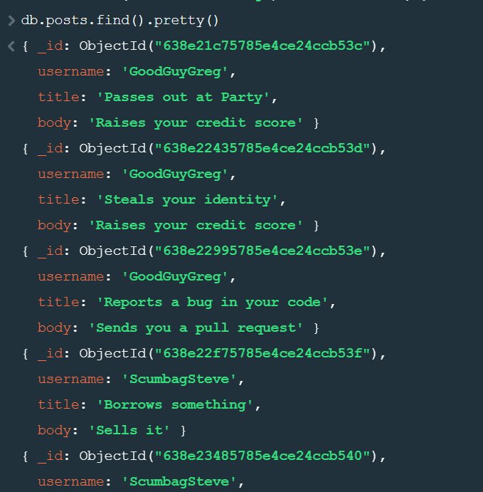

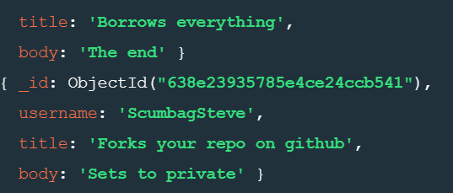

**3. Find all posts that was authored by "GoodGuyGreg".**

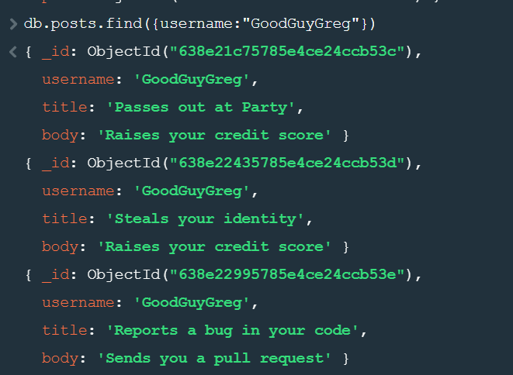

**4.Find all posts that was authored by " ScumbagSteve".**

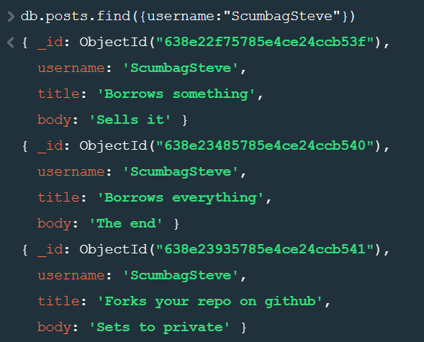

**5.** **find all comments.**

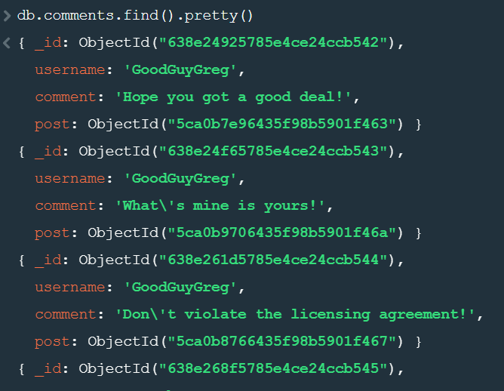

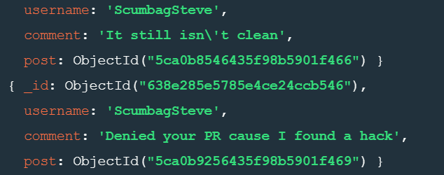

**6. Find all comments that was authored by "GoodGuyGreg"**

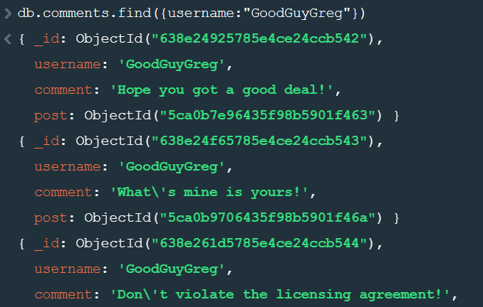

**7. Find all comments that was authored by "ScumbagSteve".**

